Supplementary Figure 1: The transparent zones formed by the recombinant E. coli BL21(DE3) expressing different Lactobacillus feruloyl esterases. FaeLac was derived from Lb. acidophilus. FaeLam was derived from Lb. amylovorus. FaeLcr was derived from Lb. crispatus. FaeLfa was derived from Lb. farciminis. FaeLfe was derived from Lb. fermentum. FaeLga was derived from Lb. gasseri. FaeLhe was derived from Lb. helveticus. FaeLjo1 and FaeLjo2 were derived from Lb. johnsonii. FaeLre was derived from Lb. reuteri.
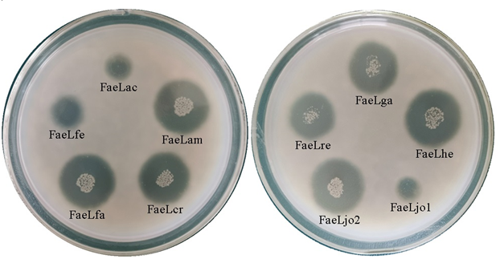

Supplementary Table 1: Oligonudeotide primers used in this study
Primer | Sequence(5’-3’) | Template
FaeLac-F | taagaaggagatatacatATGTCTCGCATTACAATTG | Lb. acidophilus
FaeLac-R | gtggtggtggtggtgctcgagAAATAGGGGCTTCAAAAATTC | Lb. acidophilus
FaeLam-F | taagaaggagatatacatATGTCCCGCATTACAATTG | Lb. amylovorus
FaeLam-R | gtggtggtggtggtgctcgagGAATAATGGTTTTAAAAATTG | Lb. amylovorus
FaeLfa-F | taagaaggagatatacatATGAAAGTAGAAATTAAAC | Lb. farciminis
FaeLfa-R | gtggtggtggtggtgctcgagATCCAACATGAATTTTGTC | Lb. farciminis
FaeLfe-F | taagaaggagatatacatATGGAAGTTGCAATCAAG | Lb. fermentum
FaeLfe-R | gtggtggtggtggtgctcgagCGGTTTAAGAAATCGGCCAC | Lb. fermentum
FaeLga-F | taagaaggagatatacatATGGCAACAATTACAATTG | Lb. gasseri
FaeLga-R | gtggtggtggtggtgctcgagAAAAGTATTATTATCTTGTAAAAAT | Lb. gasseri
FaeLhe-F | taagaaggagatatacatATGTCCCGCATTACGATTGAAAGA | Lb. helveticus
FaeLhe-R | gtggtggtggtggtgctcgagAAACGCAGGTTTTAAAAATTGCG | Lb. helveticus
FaeLjo1-F | taagaaggagatatacatATGGAGACTACAATTAAACGTG | Lb. johnsonii
FaeLjo1-R | gtggtggtggtggtgctcgagTTTTATTAAAAACTCACCAAC | Lb. johnsonii
FaeLjo2-F | taagaaggagatatacatATGGCAACAATTACACTTG | Lb. johnsonii
FaeLjo2-R | gtggtggtggtggtgctcgagAAACGCATTATTATTCTG | Lb. johnsonii
FaeLre-F | taagaaggagatatacatATGGAAATAACAATCAAACG | Lb. reuteri
FaeLre-R | gtggtggtggtggtgctcgagATTTTTTAAAAAGTTAGCTAC | Lb. reuteri

Supplementary Table 2: The extracellular enzymatic activity and protein concentration of the recombinant E. coli when the maximal activities were detected
Feruloyl esterase | Maximal activity detected at (h) | Extracellular enzymatic activity (U/L) | Extracellular protein concentration (mg/L)
FaeLac | 24 | 88.9 | 51.5
FaeLam | 24 | 2306.0 | 219.0
FaeLcr | 48 | 2118.5 | 201.7
FaeLfa | 24 | 2089.8 | 93.4
FaeLfe | 12 | 1804.3 | 106.1
FaeLga | 24 | 590.4 | 146.6
FaeLhe | 24 | 2164.0 | 135.7
FaeLjo1 | 12 | 294.9 | 50.0
FaeLjo2 | 12 | 662.5 | 77.7
FaeLre | 8 | 2092.3 | 149.5
Activity was determined in 100 mM sodium phosphate buffer (pH 7.0) at 37 °C using 1 mM ρNPF as substrate. Value are means. Standard deviation for extracellular enzymatic activity not more than 35.1 U/L, and standard deviation for extracellular protein concentration not more than 12.6 mg/L.

